1 man Command to get help about commands

2. uname Print System information

C:\Users\admin\Pictures\Screenshots\Screenshot 2024-10-07 182953.png

3. pwd Print current directory

C:\Users\admin\Pictures\Screenshots\Screenshot 2024-10-07 182953.png

4. hostname Print IP address and hostname of the machine



5. date Find today’s date



6. cal Print calendar for current year

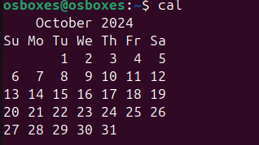

7. ls, dir See directory structure

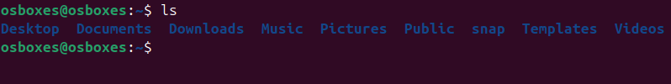

8. cat Create file

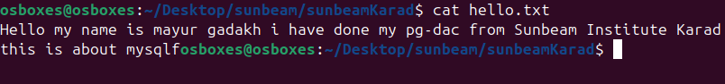

9. cat >> Append some text into existing file

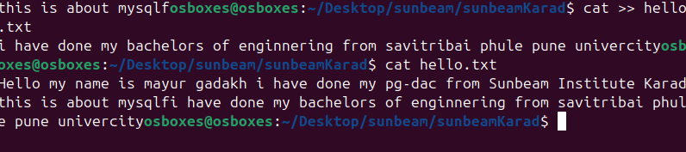

10. cp Copy a file, Copy a directory

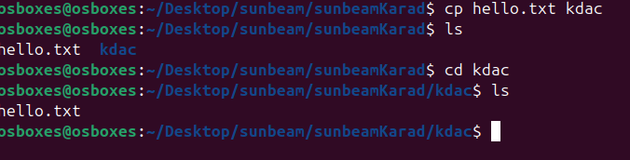

11. mv Move the files

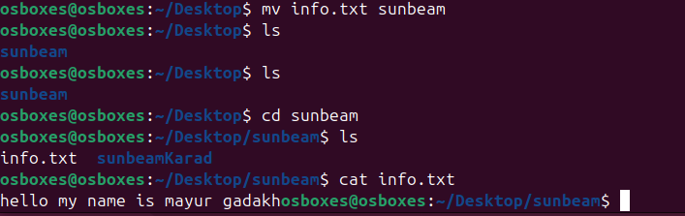

12. mv Rename a file

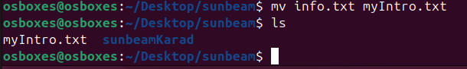

13. tac, rev Print the file in reverse order, Reverse each line in the file

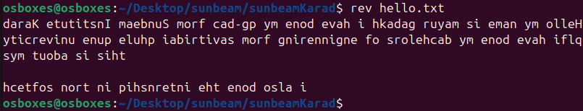

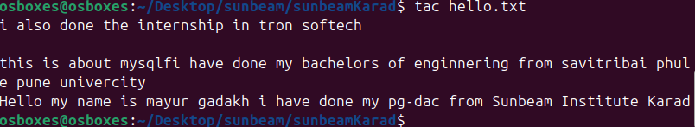

14. wc Count the words, characters and lines in a file



15. mkdir Create directory

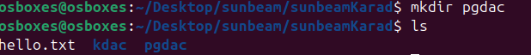

16. cd Change current directory



17. rm Remove a file, remove a directory ( with -R )

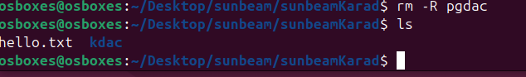

18. rmdir remove empty directory

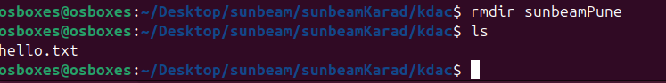

19. touch change the modification time , Create Multiple empty files at once

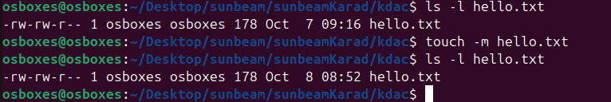

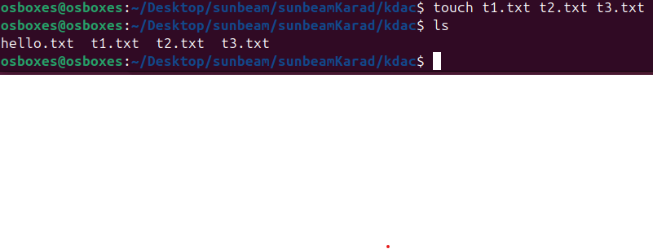

20. sort Sort file.

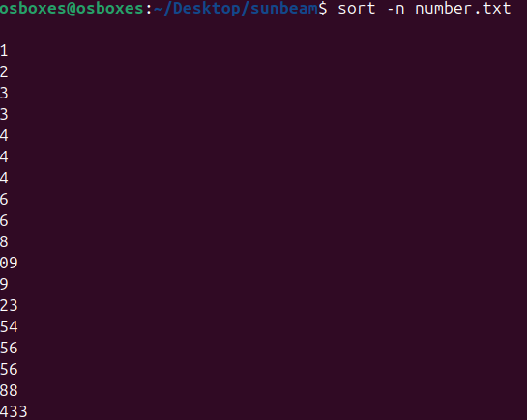

21. uniq Avoid repetition in a file.

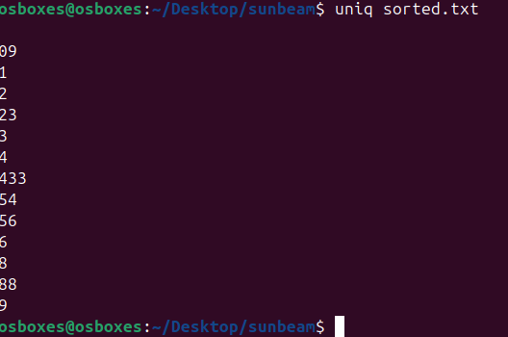

22. head Print the specified number of lines from top in the file.

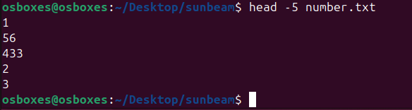

23. tail Print the specified number of lines from bottom in the file.

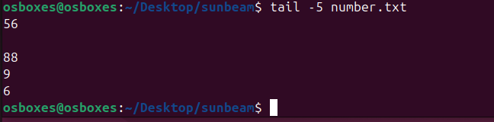

24. factor Find the factors of a number

25. alias Create command shortcut

26. unalias remove the command shortcut

27. echo Print environment variables individually

28. ps Print current processes

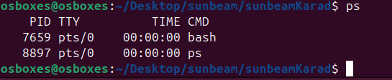

29. kill Kill the process

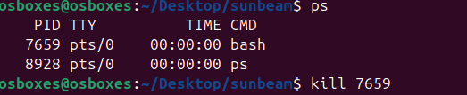

30. env